**DML**

insert into UnitAreaValueTable(description,status,zone,uav) values("1","Tenanted","1",5.00);

insert into UnitAreaValueTable(description,status,zone,uav) values("1","Tenanted","2",4.00);

insert into UnitAreaValueTable(description,status,zone,uav) values("1","Tenanted","3",3.60);

insert into UnitAreaValueTable(description,status,zone,uav) values("1","Owner","1",2.50);

insert into UnitAreaValueTable(description,status,zone,uav) values("1","Owner","2",2.00);

insert into UnitAreaValueTable(description,status,zone,uav) values("1","Owner","3",1.80);

insert into UnitAreaValueTable(description,status,zone,uav) values("2","Tenanted","1",4.00);

insert into UnitAreaValueTable(description,status,zone,uav) values("2","Tenanted","2",3.50);

insert into UnitAreaValueTable(description,status,zone,uav) values("2","Tenanted","3",3.00);

insert into UnitAreaValueTable(description,status,zone,uav) values("2","Owner","1",1.80);

insert into UnitAreaValueTable(description,status,zone,uav) values("2","Owner","2",1.60);

insert into UnitAreaValueTable(description,status,zone,uav) values("2","Owner","3",1.20);

insert into UnitAreaValueTable(description,status,zone,uav) values("3","Tenanted","1",3.00);

insert into UnitAreaValueTable(description,status,zone,uav) values("3","Tenanted","2",2.50);

insert into UnitAreaValueTable(description,status,zone,uav) values("3","Tenanted","3",2.00);

insert into UnitAreaValueTable(description,status,zone,uav) values("3","Owner","1",1.25);

insert into UnitAreaValueTable(description,status,zone,uav) values("3","Owner","2",1.00);

insert into UnitAreaValueTable(description,status,zone,uav) values("3","Owner","3",0.75);

insert into UnitAreaValueTable(description,status,zone,uav) values("RCC buildings","Tenanted","Zone A",5.00);

insert into UnitAreaValueTable(description,status,zone,uav) values("RCC buildings","Tenanted","Zone B",4.00);

insert into UnitAreaValueTable(description,status,zone,uav) values("RCC buildings","Tenanted","Zone C",3.60);

insert into UnitAreaValueTable(description,status,zone,uav) values("RCC buildings","Owner","Zone A",2.50);

insert into UnitAreaValueTable(description,status,zone,uav) values("RCC buildings","Owner","Zone B",2.00);

insert into UnitAreaValueTable(description,status,zone,uav) values("RCC buildings","Owner","Zone C",1.80);

insert into UnitAreaValueTable(description,status,zone,uav) values("RCC buildings with cement or red-oxide flooring","Tenanted","Zone A",4.00);

insert into UnitAreaValueTable(description,status,zone,uav) values("RCC buildings with cement or red-oxide flooring","Tenanted","Zone B",3.50);

insert into UnitAreaValueTable(description,status,zone,uav) values("RCC buildings with cement or red-oxide flooring","Tenanted","Zone C",3.00);

insert into UnitAreaValueTable(description,status,zone,uav) values("RCC buildings with cement or red-oxide flooring","Owner","Zone A",1.80);

insert into UnitAreaValueTable(description,status,zone,uav) values("RCC buildings with cement or red-oxide flooring","Owner","Zone B",1.60);

insert into UnitAreaValueTable(description,status,zone,uav) values("RCC buildings with cement or red-oxide flooring","Owner","Zone C",1.20);

insert into UnitAreaValueTable(description,status,zone,uav) values("Tiled/Sheet of all kinds","Tenanted","Zone A",3.00);

insert into UnitAreaValueTable(description,status,zone,uav) values("Tiled/Sheet of all kinds","Tenanted","Zone B",2.50);

insert into UnitAreaValueTable(description,status,zone,uav) values("Tiled/Sheet of all kinds","Tenanted","Zone C",2.00);

insert into UnitAreaValueTable(description,status,zone,uav) values("Tiled/Sheet of all kinds","Owner","Zone A",1.25);

insert into UnitAreaValueTable(description,status,zone,uav) values("Tiled/Sheet of all kinds","Owner","Zone B",1.00);

insert into UnitAreaValueTable(description,status,zone,uav) values("Tiled/Sheet of all kinds","Owner","Zone C",0.75);

DB: data for TaxRecordTable

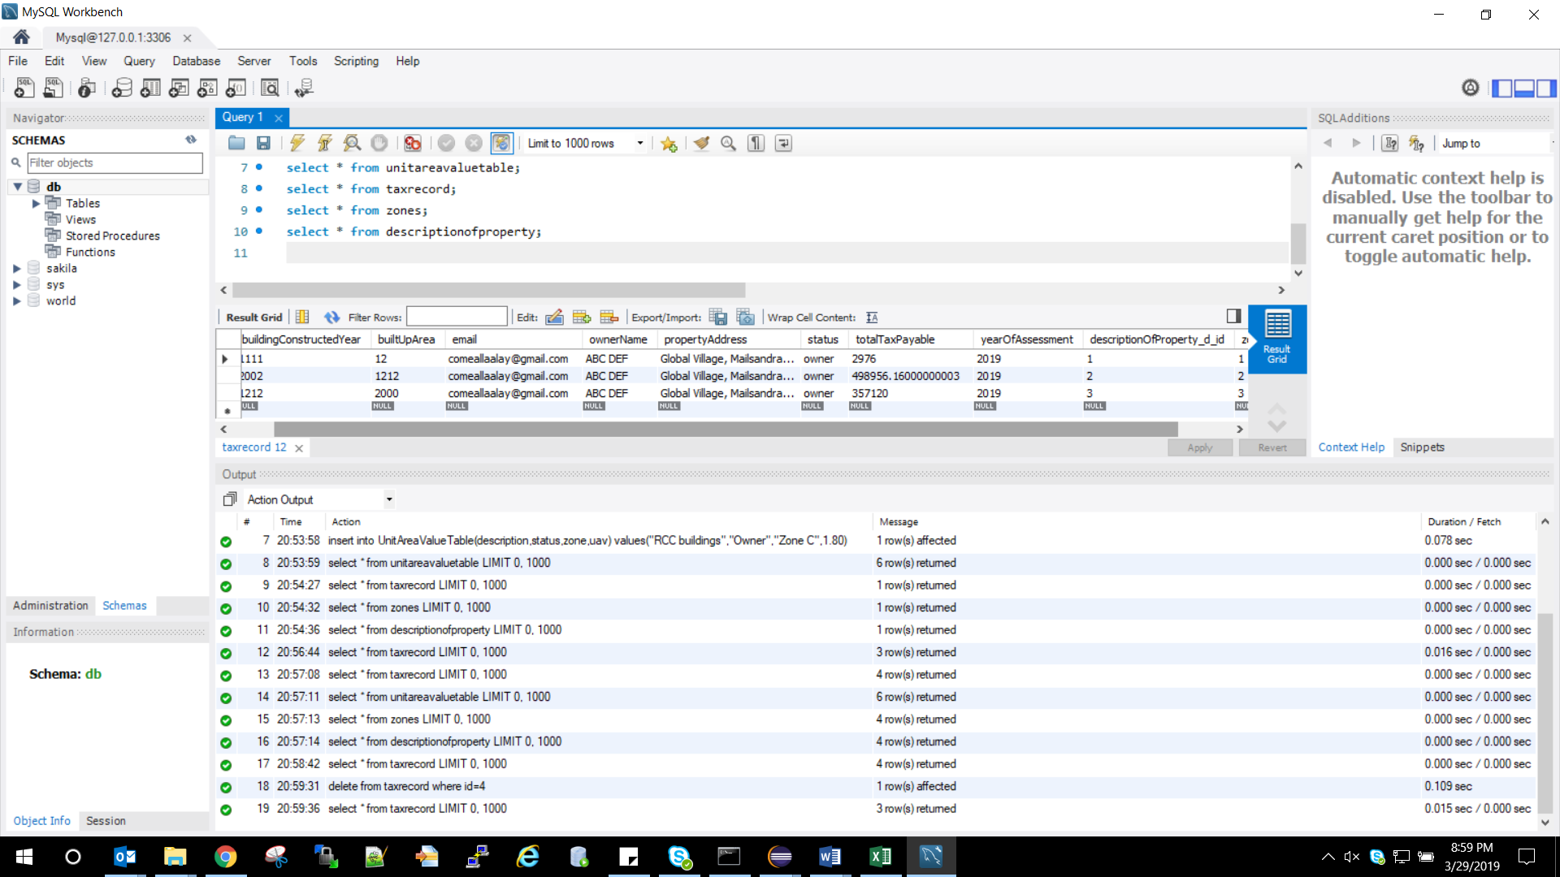

**Index Page**

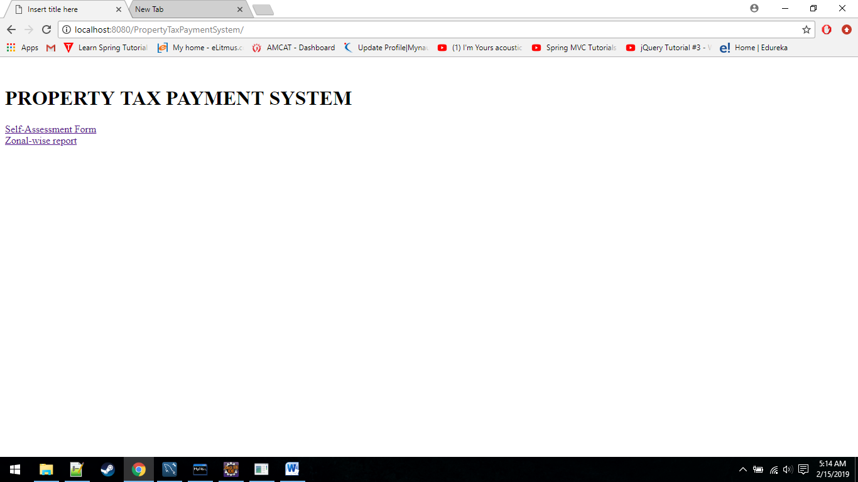

Self Assessment form Page

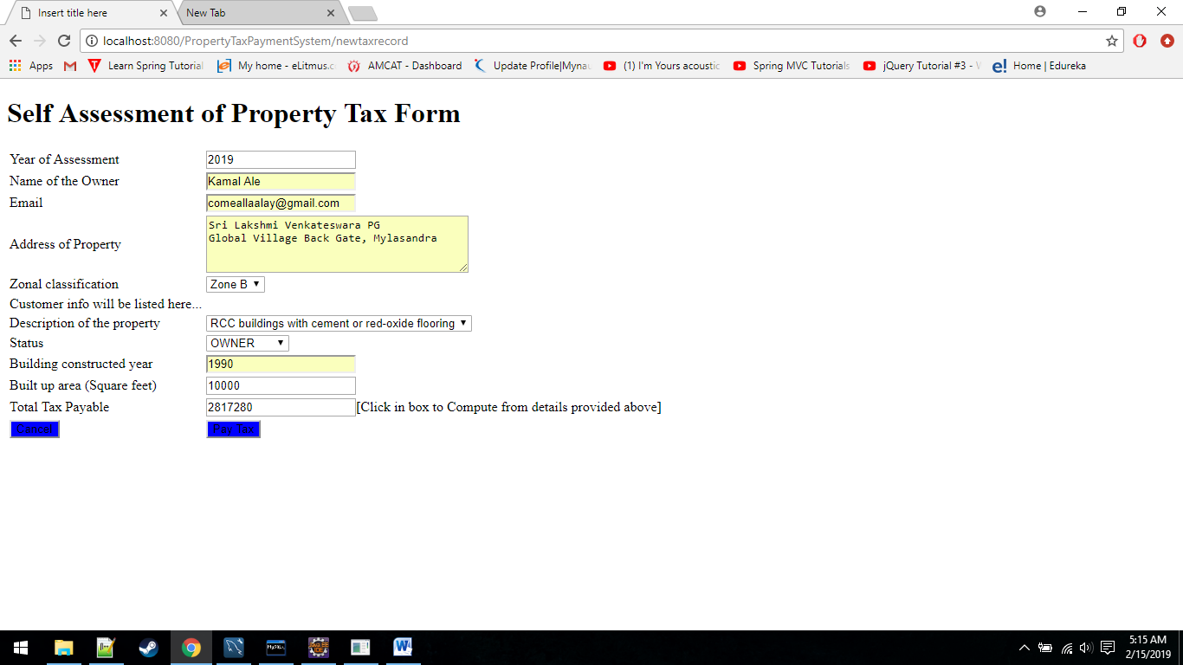

Zonal Wise Report Page

